AKSHAYA FASHIONS

MARKETING PLAN

1. Design and Offer stylish and high-quality traditional clothing.
2. Expand online presence and sales of traditional wear.
3. Prioritize customer satisfaction and service for traditional apparel.
4. Promote eco-friendly and sustainable practices in traditional fashion.
5. Foster brand loyalty and community engagement with a focus on traditional attire.

Objective :

Authors of

Document : Akshaya

([akshayafashions75@gmail.com](mailto:akshayafashions75@gmail.com))

Table of contents: 

* Business Summary
* Content Marketing Goals
* Target Audience
* Content Strategy
* Content calendar
* Promotion Plan
* Measurement Plan
* Budget

**BUSINESS SUMMARY**

Company Name :

Akshaya fashions

Mission Statement :

At Akshaya Fashions, we are dedicated to preserving and celebrating the timeless elegance of traditional clothing. Our mission is to craft high-quality, sustainable and stylish traditional wear that not only enriches the beauty of our customers but also honours the heritage and culture behind each garment. We committed to providing exceptional service and fostering a sense of belonging within our community, all while maintaining eco-friendly practices in the world of traditional fashion. Our goal is to be your trusted source for authentic and contemporary traditional attire that transcends generations.

Products for Services :

* Traditional Clothing collections
* Accessories
* Custom Tailoring
* Seasonal collections
* Kids Traditional and trendy wear
* Women and Men Traditional and Trendy wear
* Online shopping
* Personal styling
* Alterations and tailoring
* Virtual Try-On
* Worldwide Shipping

Business Goals :

To increase annualsales, improve its online presence while enhancing customer satisfaction and implementing sustainable practice to reduce it environmental impact. Collaborations with influencers and expansion into new markets are also key objectives.

**CONTENT MARKETING GOALS**

Increase brand awareness

* Create visually appealing content to showcase the brand's traditional clothing.
* Maintain an active presence on social media platforms.
* Publish informative blog posts about traditional clothing and culture.
* Collaborate with fashion influencers for wider reach.
* Share customer testimonials and success stories.
* Send engaging email campaigns.
* Optimize website content for search engine visibility.

,m,l,ml,bnkjo

Boost sales and improve customer engagement

* Create content that highlights product benefits and encourages purchases.
* Develop compelling product descriptions and visuals to drive sales.
* Send personalized email campaigns to engage and re-engage customers.
* Promote limited-time offers and discounts to incentivize purchases.
* Share user-generated content to build trust and foster engagement.

Drive traffic to website

* Optimize website content for search engines to improve organic traffic.
* Create engaging and shareable content on social media to direct users to the website.
* Publish regular blog posts on relevant topics to attract visitors.
* Promote website links in email campaigns and newsletters.
* Collaborate with influencers to drive traffic through their content.
* Use paid advertising on social media and search engines to increase website visits.
* Leverage user-generated content to showcase on the website.
* Encourage sharing of website content through social sharing buttons.
* Monitor website analytics to track traffic sources and make data-driven improvements.
* Focus on mobile optimization to ensure a seamless experience for mobile users.

Generate leads

* Develop lead magnets such as fashion guides or exclusive offers to capture potential customer information.
* Create landing pages that effectively convert website visitors into leads.
* Promote these lead magnets through social media and email campaigns.
* Host webinars or virtual events to gather contact information from attendees.
* Implement a chatbot on the website to engage with visitors and collect leads.
* Use targeted content marketing to attract users interested in traditional fashion.
* Encourage newsletter sign-ups and offer incentives for subscription.
* Collaborate with influencers to promote lead-generating campaigns.
* Leverage social media advertisiements.

The target audience for Akshaya Fashions are

**TARGET AUDIENCE**

**1) Men**

We are providing high quality men’s wears in a lowest price for all age groups. Some of them include:

Trousers, shirts, jeans,suits,sweaters,gloves,jackets,hats, etc.,

**2) Women**

We are manufacturing authentic and beautiful traditional as well as trendy clothing for women of all the ages.

Skirts, dresses, shirts, sweaters, trousers,coats, chemises, jeans, ets.,

**3) Children**

Children need clothing that is mild on the skin because their skin is sensitive. We produce those types of soft fabrics for all age group of children.

School uniforms for all the schools, t-shirts, tops, jeans for both boys and girls.

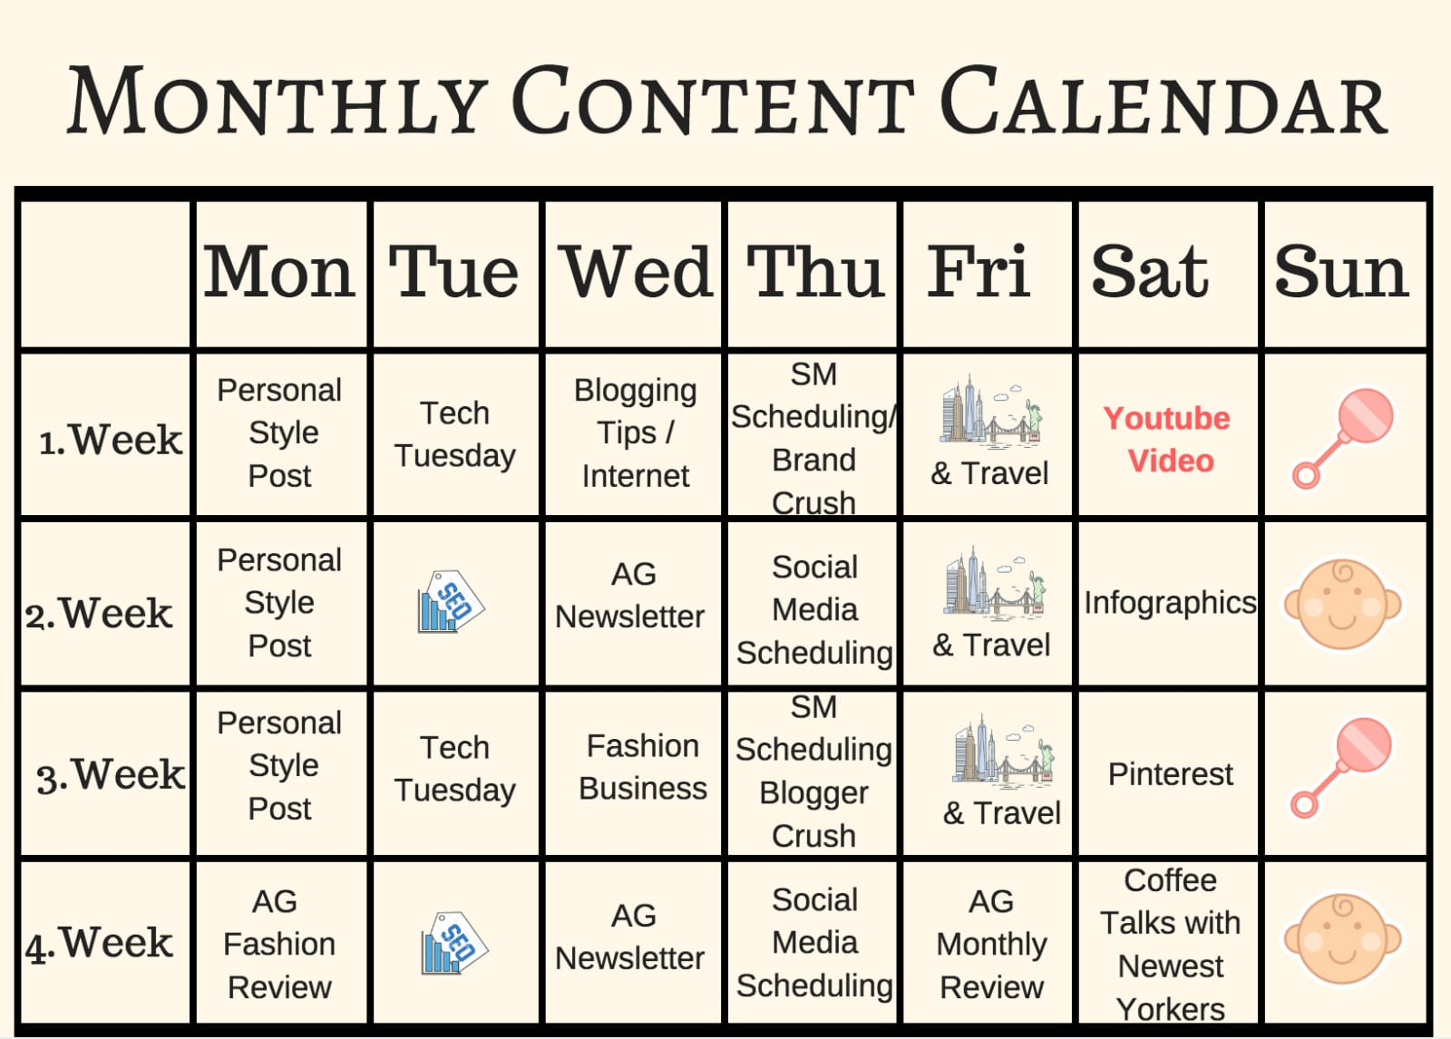

**CONTENT CALENDER**

**OUR MARKETING CHANNELS**

**PROMOTION PLAN**

Over the course of the year, we will launch (or ramp up) our use of the following channels for educating our customers, generating leads, and developing brand awareness:

|  |  |
| --- | --- |
| Webinars | |
| Purpose of channel | Brand awareness, customer acquisition, and client engagement. |
| Metrics to measure success | Webinar signups, signup-to-attendance rate, attendee-to-QL rate. |

|  |  |
| --- | --- |
| Instagram | |
| Purpose of channel | Employee branding, company brand awareness, visual engagement. |
| Metrics to measure success | Followers, likes. |

|  |  |
| --- | --- |
| Facebook | |
| Purpose of channel | Audience reach, Brand awreness,Customer engagement. |
| Metrics to measure success | Followers, likes. |

|  |  |
| --- | --- |
| Blog | |
| Purpose of channel | Content hub, Educational resources, Search engine visibility, Brand storytelling |
| Metrics to measure success | Followers, likes, views, Support |

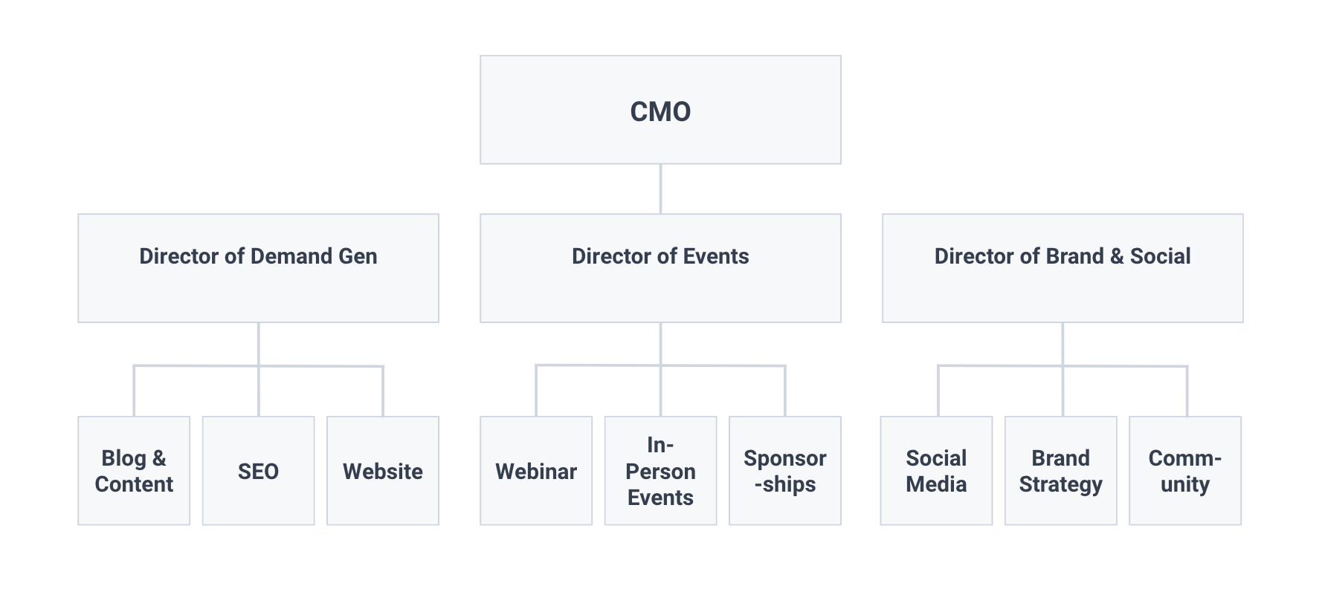

MARKETING STRATEGY

We will utilize the following technologies and software to help us achieve our goals and objectives.

## Marketing CRM

We use [https://app.hubspot.com/user-guide/44189262?via=home,](https://app.hubspot.com/user-guide/44189262?via=home,%20) as it integrates our marketing, sales, and customer service software in one central location. It also connects us to a suite of other marketing tools our team (and our customer base) utilizes.

## Email Marketing Software

Our mail [akshayafashions75@gmail.com](mailto:akshayafashions75@gmail.com) enables us to send mass communications to our customer base, enroll our webinar registrants in nurture streams before and after their attendance, and enable salespeople to communicate in sync with marketing.

## Blogging Software

Blogger <https://akshayafashions75.blogspot.com/> and CMS allows us to quickly write, publish, and historically optimize our blog posts. We hold ourselves to a three-times-a-week publication cadence, and HubSpot lets us churn out interactive content quickly.

## Social Media Management Software

We manage our social media publishing with facebook <https://www.facebook.com/profile.php?id=61552765612393> & . We can post on multiple platforms and see engagement in one place.

Creating a measurement plan is essential to track the success of your brand's marketing efforts. Here's a simplified measurement plan for Akshaya_fashions:

**Goals:**

* Increase brand awareness.
* Boost sales and revenue.
* Improve customer engagement.
* Drive website traffic.

**Key Performance Indicators (KPIs):**

**MEASUREMENT PLAN**

**Brand Awareness:**

* Social Media Reach and Engagement.
* Website Traffic Growth.
* Follower Count on Social Media Channels.

**Sales and Revenue:**

* Monthly Sales Revenue.
* Conversion Rate (Website Visitors to Customers).
* Average Order Value.

**Customer Engagement:**

* Social Media Likes, Shares, and Comments.
* Email Open Rates and Click-Through Rates.
* Customer Feedback and Reviews.

**Website Traffic:**

* Total Website Visitors.
* Referral traffic engines.
* Social media usages.
* Using website tools to make advt

**Tools and Analytics:**

Google Analytics: Track website traffic, user behavior, and conversions.

Social Media Insights: Monitor engagement metrics on social platforms.

Email Marketing Analytics: Analyze email campaign performance.

Customer Relationship Management (CRM) Software: Track customer interactions and feedback.

**Measurement Frequency:**

Regularly: Daily or weekly tracking of social media engagement.

Monthly: Review website traffic and sales data.

Quarterly: Analyze customer engagement and brand awareness data.

**Data Analysis and Reporting:**

Regularly review KPIs against set goals.

Identify which marketing channels and strategies are most effective.

Make data-driven decisions to refine marketing efforts.

**Adjustment and Optimization:**

Modify marketing strategies and content based on data insight.

Invest more resources in the most successful marketing channels.

J

**BUDGET**

Over the course of this year, given the cash allotted to the Marketing team, we expect to invest in the following items to ensure we meet the objectives outlined in this marketing plan:

|  |  |
| --- | --- |
| **Marketing Expense** | **Estimated Price** |
| Marketing Software | **Rs.5000** |
| Event Sponsorships | **Rs.5000** |
| Paid Social | **Rs.12,000** |
| Paid Search | **Rs.30,000** |
| **Total** | **Rs.57,000** |